


CIRCABC Leader guide

Author | Claudine Tayot – SOGETI Luxembourg
Revised by
Approved by
Creation date | 20/05/07
Revising date | 20/12/07
Version number | 1.0

CIRCABC Leader guide 1
1 About the CIRCABC Leaders guide 4
1.1 Guide main objective 4
1.2 Audience 4
1.3 Structure 4
2 First-time leader 5
2.1 First steps towards your IG 5
2.2 For whom will your Interest Group be available? 6
3 How to let people join your Interest Group 6
3.1 To know more about the access profiles 6
3.1.1 About the access profiles 6
3.1.2 About the roles 7
3.1.3 How to customise access profiles 7
How to customise default access profiles 8
How to create and modify dynamic access profiles 8
3.2 How to invite a new user to your IG 9
3.2.1 Whom to invite? 9
Invite someone having applied for Membership. 10
Invite someone who has not applied for membership. 10
How to create a new CIRCABC user 10
How to invite a new user 12
3.3 List the members of your Interest Group 14
3.4 How to remove membership 15
3.5 How to change the access profile of a member 15
3.6 Help users with lost access codes (for further release) 16
3.6.1 Help users with lost password 16
Self-Resent password 17
Reset password 17
3.6.2 Help users with lost user name 17
4 The Library's corner 18
4.1 What shall we learn? 18
4.2 What is this for? 18
4.3 Whom is the Library intended for? 18
4.4 What does it look like? 18
4.5 Organising a Library 19
4.5.1 Creating sub-spaces in a library 19
Who can create spaces? 19
How can I create a sub-space in the library of my Interest Group? 19
By creating a new space 19
By copying a space 19
4.5.2 How to delete or recover sub-spaces: 20
Deleting a sub-space of the Library 20
Recovering the deleted spaces 21
Are there restrictions in recovering spaces? 21
Where is this function available from? 21
How to retrieve deleted items 21
How can I recover deleted spaces? 22
4.5.3 Some more actions (move, rename) 23
How to move a sub-space 23
How to rename a sub-space 24
4.6 Managing the content of a library 24
4.6.1 About multilingualism 24
Dealing with multilingualism 24
Some more about multilingual spaces 24
What is a multilingual space? 24
How can I make a space multilingual? 24
4.6.2 How to add content 25
4.6.3 Deleting or recovering content 25
Deleting content 25
Recovering deleted content 26
4.6.4 How to deal with content versioning 26
About Versioning 26
How to follow up the versioning of a content 26
4.6.5 How to update, edit and modify a content 27
Updating a content 27
Check out/in 27
4.7 Managing the Library users 27
4.7.1 Which roles for the Library? 27
4.7.2 Changing a user's role in a space of the Library (for further release) 28
How to give more rights 28
5 About the general and advanced search 31
5.1 Which kind of search? 31
5.1.1 The general search 31
5.1.2 Build detailed queries with the advanced search 31
5.2 Save and re-use queries 31
6 As a manner of conclusion 32

About the CIRCABC Leaders guide
Before coming to reading this guide, it is highly recommended to consult the Alfresco tutorial (http://www.alfresco.com/products/docs/), CIRCABC being based on Alfresco, an Open Source Software. It is also recommended to read the CIRCABC users guide.

Guide main objective
This guide explains the actions the Interest Group Leaders (IG Leaders) are able to perform in order to successfully manage the users, the services and the contents which are under their responsibility.

Audience
This guide is intended for the Interest Group Leaders. First-time leaders will find there all what they need to know for the daily management of their Interest Group (also called IG). Advanced leaders, who are used to navigate in CIRCA, can find information about features specific to CIRCABC.

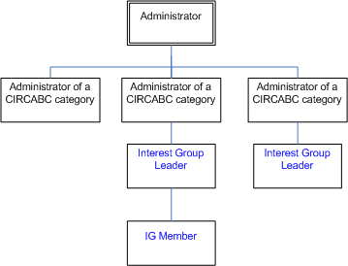
The tree of responsibilities within CIRCABC

You have been granted IG leader access profile by:
- Either the administrator of your CIRCABC category;
- Or another Leader of this Interest Group.

Structure
This guide complements the User Guide with features specific for the Interest Group Leaders.

Those who are both first-time leader and first-time user are warmly advised to consult the CIRCABC Users Guide, first. The CIRCABC Users Guide will help you better understand your users' needs by initiating you into most of the actions any member of an Interest Group can perform.

First-time leader
The role of the leader of an interest group has been assigned to you by either the administrator of a CIRCABC category or another leader of this IG.

First steps towards your IG
The Interest Group (IG) you shall lead is an element of a category of Interest Groups (CIRCABC category).
Any IG is characterized by a group of users (potentially unlimited), a set of services (Library service, Newsgroups, etc) and a collection of contents articulated along a main theme.

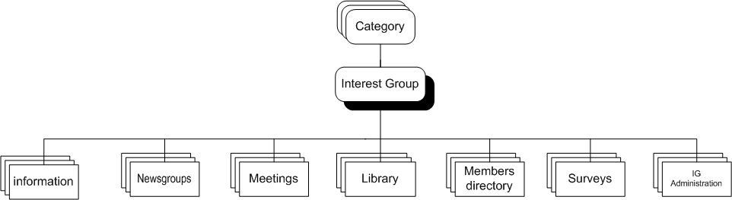
Overview of the IG services

The services will be detailed from the standpoint of the Leader. Before coming to more information, let us shortly present each of them:
Library: the main service in your IG. It receives your documentary content.
Members: lists the members of your Interest Group.
Information: short description of the IG; public information about how to join the IG (for further release).
Newsgroups: enables to take part into or create discussions.
Meetings: for organising and attending virtual meetings. This service will be delivered with a further version of CIRCABC.
Surveys: allows to prepare and to launch surveys (for further release).
IG Administration: provides with IG management tools.

All of these services can be reached through the "main menu" of your Interest Group Welcome page.

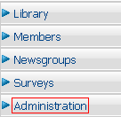
Click "Administration" and find tools to manage your IG and its members

You are responsible for managing users who participate, or wish to participate, in your own Interest Group. The services offered by your IG are under your responsibility.

Notice however that acting as the leader of your IG does not provide you with any right on the other Interest Groups.

For whom will your Interest Group be available?
As an IG leader, you may decide whether your Interest Group (or a part of your group) will be public or for membership.

Membership is the default status of any just created interest group. To change this status, you will select the service "Administration".

If you opt for membership, you will have to invite CIRCABC users to join your Interest Group.

How to let people join your Interest Group
Each member can access each IG service proportionally to the role he/she is intended to play. In this prospect, each newcomer is granted with an IG access profile.

We shall learn some more about the access profiles and about how to manage them.
Once you will use, modify, even create or delete access profiles, fluently, we shall see how to assign them to anybody who would like to participate in the life of your Interest Group.

To know more about the access profiles

About the access profiles
The access profile you assign to new members should mirror the way in which they would like to participate in your IG. Each access profile consists of a family of rights to collaborate in the various services of your Interest Group.

Each CIRCABC user may be a member of several IGs. Users have an access profile per Interest Group in which they are involved. For instance, you may invite as leader a colleague who participates in other Interest Groups with very few rights.

Your IG is delivered to you with a set of default access profiles. These are:
IG Leader: the IG leaders administrate all the services of their Interest Group.
IG Author: the authors participate in the Library and in the Newsgroups. They can create contents; they can edit any content but may delete their own contents only. They can access and post news. They can access the Members service. They can encode surveys.
IG Contributor: the IG contributors participate in the Library and in the Newsgroups. They can create contents. They can edit only their own contents; they can delete only their own contents. They can access and post news. They can access the Members service. They can encode surveys.
IG Reviewer: users granted with this profile participate in the Library and in the Newsgroups. They can edit every content but cannot create nor delete any. They can access and post news. They can participate in a discussion. They can access the Members service. They can encode surveys.
IG Access: those who are only given the IG Access profile can just read and download contents of the Library. They can only read posts in the Newsgroups. They can browse the Members service and access surveys.

Besides these, there are two additional profiles:
Registered: the 'registered' users may apply for membership. The Interest Group Leader can grant them with access to the contents.
Public: The public users have no user name nor password so that they cannot apply for membership. The Interest Group Leader, however, can set rights for public users.

About the roles
The roles are the smallest components of the access profiles. Each access profile includes one role per service.

The roles will be further described in the detailed presentation of each service. However, the below table of the roles available for the Library provides an example of the rights attached to some roles.

No access: this means that you cannot even read contents;
Access: read only; you can only download contents items as well as their properties;
Edit only: you can only edit any content item; you cannot create nor delete any.
Manage own: you can create, edit and delete your own contents. You can only access the documents created and managed by the other members.
Full Edit: you can create, edit and delete your own contents; you can edit any content whoever be its author.
Administrate: you can manage the service to which this right is applied.

How to customise access profiles
On creation by a CIRCABC category administrator, your Interest Group has been implemented with default access profiles. You can use them as-is or customised. For instance you can, for a given profile, narrow down the right to access the library while extending access to the newsgroups… You can even set access profiles from nothing.

Do not forget, however, that modifying an access profile affects all the members who have been assigned this profile.

Further to customising, access profiles with a same name but depending on different Interest Groups may differ from one another. So, keep in mind that the access profiles you define are taken into consideration only within your Interest Group.

How to customise default access profiles

You are allowed to:
- Rename an access profile;
- Change some (or all) of the roles it is made of.

Do not forget that you cannot:
- Modify nor delete the IG Leader profile;
- Delete any Default Access Profile;
- Attach rights other than 'Access only' or 'no access' to the 'Public' or 'Registered' profiles.

The "More actions/edit, manage profiles" command (in the top toolbar on the welcome page of your Interest Group Administration service) allows you to edit and modify the default access profiles. It takes you to a list of the default access profiles. As shown below, scrolling lists enable you to change any role of any service in each profile. Once done, you validate the modifications by clicking OK.

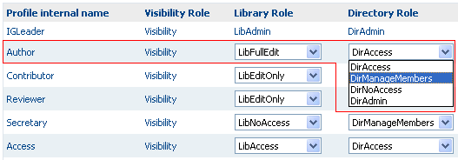
We change the role attached to the "Members" service for the access profile "Author"

How to create and modify dynamic access profiles
Creating a Dynamic Access Profile means:
- attach one role to each service of your IG;
- give a name to the access profile so created.

The Dynamic Access Profiles you have created only apply to the Interest Group for which they have been defined.

Select the "Administration" service and click "More actions/edit, manage profiles" (the "more actions" menu available from the upper toolbar). You will simply give a name to the new profile and select a role per service, as illustrated below.

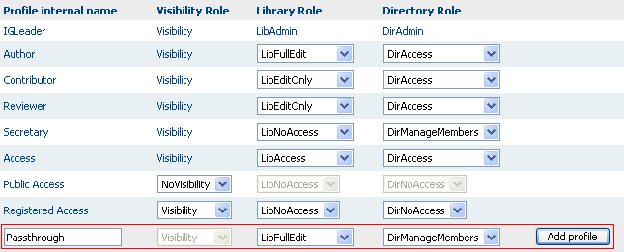

Create a dynamic Access profile

Once done, you click "Add profile". The new profile is now listed among the access profiles available for your Interest Group.

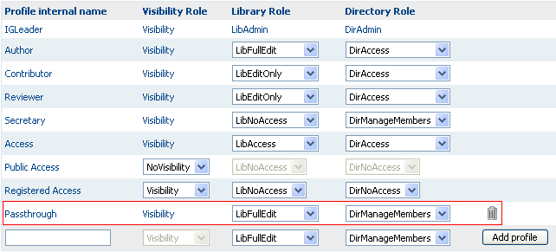
Access profile "Passthrough" has just been created

Modifying a dynamic access profile follows the below rules:
- You can modify any dynamic access profile;
- You can rename it;
- You can delete it only if it is not currently assigned to any member.

Now, you are able to manage access to the IG services. You are ready to invite new comers to take membership.

How to invite a new user to your IG
As an IG Leader you can invite new users to your Interest Group and assign them access profiles. In fact, anybody who has been granted with the "Manage Members" role over the "Members service" can invite users to join the Interest Group. Please, note however that those who have the "Manage members" role can invite a new user but they are unable to create, modify neither delete "Access profiles".

Please, keep in mind that a same user may get memberships to several Interest Groups. By offering membership, you simply provide rights to collaborate in your own IG.

Whom to invite?
Users can be invited in two manners:
- An authenticated user contacts you through the "Apply for Membership" procedure (see "Apply for Membership" in the CIRCABC Users guide);
- You invite a user on your own initiative, even if not yet existing in CIRCABC.

Invite someone having applied for Membership.
A would-be user has followed the link "Join this group" available besides the name of your interest group in the "Browse categories" page. Then user has filled out and sent the application form (for further information, see "Apply for Membership" in the CIRCABC Users guide).
To check pending applications, select "More Actions/View Member applicants" from the top bar of the "Administration" service welcome page.
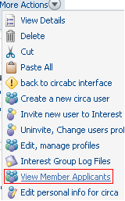
Check pending applications for membership

The page "Application for Membership" lists your Interest Group's would-be members and allows you to accept/reject applications, individually or in bulk.

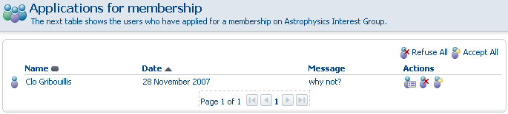
You can opt for accepting or refusing to grant membership.

Invite someone who has not applied for membership.
You are free to invite anyone having not applied for membership, even if existing not yet in your CIRCABC system. In the latter case, you will first create this new user in CIRCABC and then invite him/her to join your Interest Group.

How to create a new CIRCABC user
Select the "more actions/ create a new Circa user" command from the top-right angle of the "Administration" service welcome page…

This procedure runs over 3 steps:
Step 1:
You are requested for recording the properties of the new user. You will put there the user's person properties.
The first name, last name, postal address, phone and e-mail fields are mandatory.

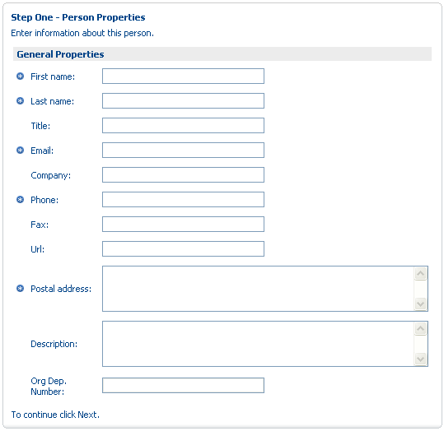
Create a new user; person properties

The top line indicates the current step. Once you have keyed in the requested data, press onto Next (in the top right box) in order to reach "step two".

Step 2:
You are now expected to assign a user name and a password to the new user. Both User name and password are mandatory.

Forgotten the rules applying to user name and password? Just take a look at the 'Register procedure' (see 'Getting a CIRCABC account', in CIRCABC Users guide).

You can also select the language in which the user will read the contents ("Content language filter" option). The users are able to change it through the "User options" section of the "Manage your account" form (available from the CIRCABC "main menu").

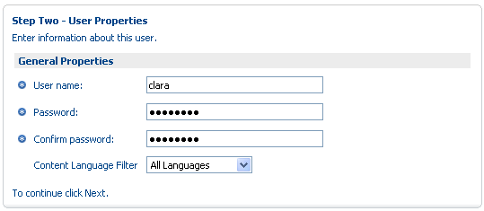
Create a new user; user properties

Once you have filled out this second form, click again on Next in order to be taken to step 3.

Step 3:
Now you have reached the last step of "create users". This is the validation step. This provides you with a summary of your transaction.
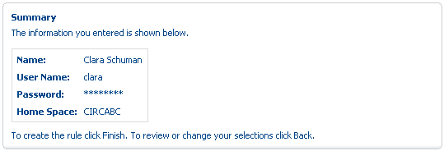
Create a new user; summary

- If you agree with the data in the summary, just click Finish. The new user is recorded as a new CIRCABC user.
- If you ever disagree and wish to modify any data, click Back. Then you modify the form and click again on Next. If you now agree with the data you have put, click Finish in order to confirm the creation of a new user.
- If you simply wish to quit the creation process and not to validate the new record, click Cancel.

The new user has been created in CIRCABC, you can now invite him/her to join your Interest Group.

How to invite a new user
Whichever user you invite, you follow the "Invite user" procedure.

You can then select any existing user, no matter whether he/she is already a member of any other Interest Group.

From the top toolbar of your IG welcome page, select "More actions / Invite new user to Interest Group"; this launches the "Circa invite user" dialog. By following the below steps, you will manage invitations to membership:

- Select the user you wish to invite;
- Select an access profile;
- Check that the right profile has been given to the right user;
- Notify the selected user that he/she is now a member of your IG. This last step is not mandatory (except for inviting applicants).

1. Select the user you wish to invite:
Insert any part of either the user first name or last name in the "user search" field of the "Select invited users and roles" pane. Please, note that you must key at least three characters in the "user search" field.
You may not invite twice a same user (once invited, the user is removed from the list of the searchable users).
You can select and invite up to 1000 users at a time.

Press onto the Search button. The search results are displayed in the results box. Now you select the user you wish to invite:

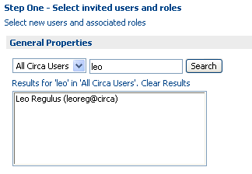
Whom to invite?

Please, notice that the users search engine reads only the first names and last names. So, do not use the User name as a search key.

Once you have selected a user, you provide him/her with an access profile.

2. Select the access profile you wish to assign
Select from the scrolling list an access profile to be assigned to this user; click Add to list.

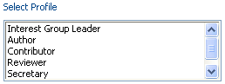
Which access profile?

Once you have chosen both a user and the access profile, press the Add to list button:

3. Check that the right access profile has been given to the right user
You have clicked on Add to list; the page is refreshed with the user identification and access profile appearing in the Name field, at the bottom of the page:

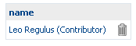
Select new Member

If you ever change your mind and definitely decide not to invite the selected user, click the trash can at the end of the "name (access profile)" line.

Notice that you can invite several new users at a same time: just repeat the 'select user' and add the results to the list of would-be memberships ("Name" list).

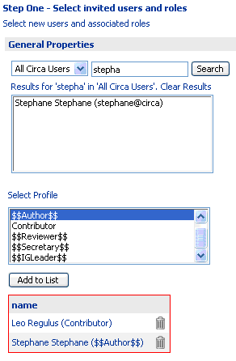
Several users are invited at a same time

Having passed through Step 1, you push the top-right Next button.

4. Notify the invited user that, as from now, he/she has membership in your IG. This is optional.
In the example below we have opted for notify:

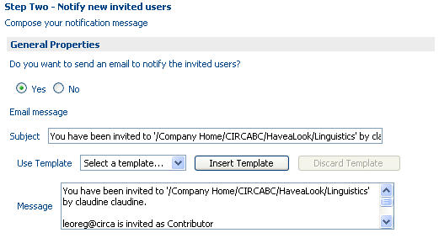
Notify or not to notify

Now, you are able to create new users, invite newcomers to participate in your Interest Group and assign them an Access Profile defining the extent of their collaboration.

So, let us go further with managing users.

List the members of your Interest Group
If looking for any member of your Interest Group …
If wishing to list all of its members…
You will consult the Members service. This can be accessed through your interest group services list.
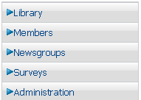
The Interest Group services list

- This way, can I list all of my interest group's users, at a time?
- Yes, provided that your Interest Group contains less than 1001 users. The "Members" search function, indeed, is unable to display more than 1000 members at a time (even if you have asked for "all CIRCABC users", "all domains" and "all profiles"). Once this limitation has been reached, you are warned by a specific message.

As illustrated below, the search form allows searching only the members of your internet group or any other CIRCABC user through options. You can take an insight in one or more domains (CIRCABC, CEC…), limit the exploration to such or such profile, etc:

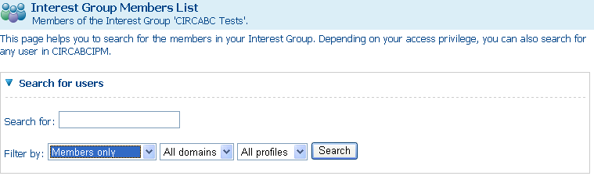
Search only the members of your internet group

How to remove membership
You can remove membership only from your own Interest Group. Removed members keep the membership they may have in other Interest Groups. You do not (and cannot) delete users from the CIRCABC users list.

You can remove any type of member. Keep in mind, however, that your Interest Group must have at least one IG Leader.

The "remove membership" procedure can be launched through the "Administration" service. Select "More Actions/Uninvite, change user profile" from the top toolbar of the "Administration" main page. You get a list of the members of your Interest Group. Click the "Remove" icon () next to the member to be removed.

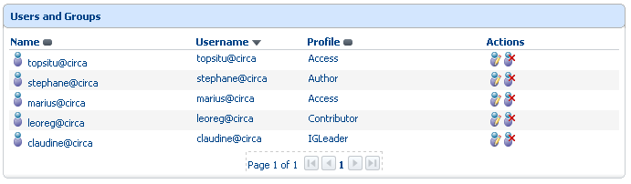
From this view, you can remove or change an access profile

You are asked for confirming your choice or cancelling the action.

How to change the access profile of a member
The access profiles are not assigned definitely. You can change the access profile of any member, at any time, what allows you to keep on offering profiles fit for greater or smaller involvement in the life of your Interest Group.
Keep in mind, as noticed above, that your Interest Group must have at least one IG Leader.

Being assigned the 'DirManage Members' role in the Members service allows modifying the access profile of any Interest Group member other than:
- the Interest Group leader(s)
- oneself.

To change access profiles, you make use of the "More Actions/Uninvite, change user profile" command. Select the user whose access profile has to be modified. Click the "change" icon () next to the user's name and profile.

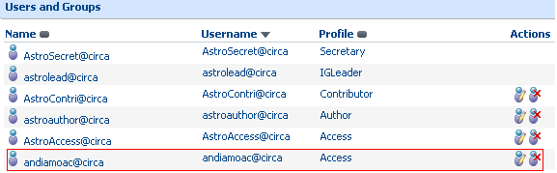
This member is granted with the access profile "Access"

Once done, you can select another access profile.
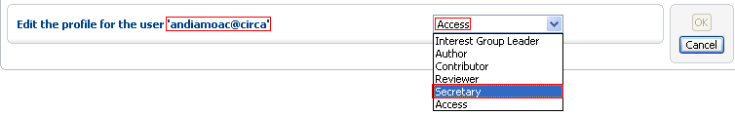
We change his access profile

You validate the modification by clicking on "OK" at the top right angle of the "Change Member's access profile" page.

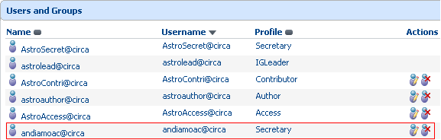
Now, this member is assigned the access profile "Secretary"

Not to forget that the user access profile is replaced only for the current Interest Group.

By combining the creation of Dynamic access profiles with the modifying profiles, you can keep in line with the needs of your Interest Group's fellow members, enabling them to collaborate in whatever way.
Keep in mind, however, that the more profiles, the more complex the IG management…

Help users with lost access codes (for further release)

Help users with lost password
Losing password is probably one of the most frequent issues any user may have to overcome. Fortunately, this can be easily solved through an automatic procedure.

Self-Resent password
A user who has lost password tries the "Did you forget your password? " link. The initial password is automatically searched on the basis of the username provided. It will be e-mailed back to the address which is stored in the Members service. For a security purpose, the user name is not e-mailed along with the password. You do not take any part in this procedure.

Reset password
A member of your IG contacts you about forgotten password… What to do? You login and select the "Members" service of your Interest Group. You look for this member and click the "change password" icon which can be found at the end of each line ().
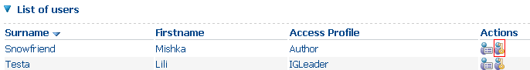
Reset password

You have to validate this automatic procedure.

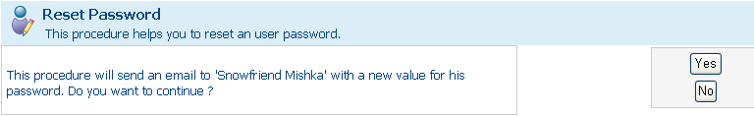
Confirm you wish to reset password

The member is e-mailed a new password while a system message confirms that the procedure has been successful.

Password successfully changed

Help users with lost user name
A member of your IG contacts you about forgotten user name. No specific procedure has been set. You will look for the requested information through the Members service and then contact back your user.
Some more advice: do not communicate both the user name and password in a same message.

To find the members' user name from the Members service, you can display the user profile of the concerned member by clicking the "View user profile" icon (). The user name appears in the subtitle of the "user profile" page which is then displayed.

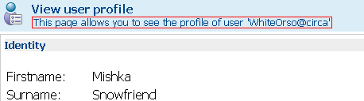
A manner to check user name

Now you know how to create new users. You are able to modify or even remove their access rights. It's time to go and explore the library.

The Library's corner

The library is the main service of your Interest Group. It is delivered together with it.
As a leader, you can administrate the Library. Such permission may be passed onto other members of your Interest Group. So, anybody who is assigned the "administrate" role in the Library is able to manage this service. "Administrate" means that you will be responsible for creating and maintaining the library. You will manage content as well as users.

What shall we learn?
We shall see how to:
- Organise a library (create and modify sub-spaces)
- Manage the content of a library (create, add or modify content)
- Manage the users of a Library

The CIRCABC Users guide offers a chapter dedicated to multilingualism (see 'How to deal with multilingualism', in CIRCABC Users guide, pp. 27-48).

What is this for?
Further explanation can be found in 'How to deal with the library' (CIRCABC users guide, p. 18).

Whom is the Library intended for?
Further explanation can be found in 'How to deal with the library' (CIRCABC users guide, p. 18).

What does it look like?
Further explanation can be found in 'How to deal with the library' (CIRCABC users guide, chapter 6, paragraph 6.1, p. 18).

Now you are familiar with the structure of the Library; let us go further and learn more about how to manage it.

Organising a Library

Creating sub-spaces in a library

Who can create spaces?
Only the "Administrate" role enables to create sub-spaces in the Library.

How can I create a sub-space in the library of my Interest Group?

By creating a new space
The library is the main service of your Interest Group.
The create space command is the quickest way of creating sub-spaces in a library.

Once you have reached your IG main page, select the "Administration" service. Click the "Library". Once the Library's main page is displayed, click create/create space from its top toolbar.
You are requested for providing a name, title and description. The name is mandatory. Then you choose an icon and press on create space:
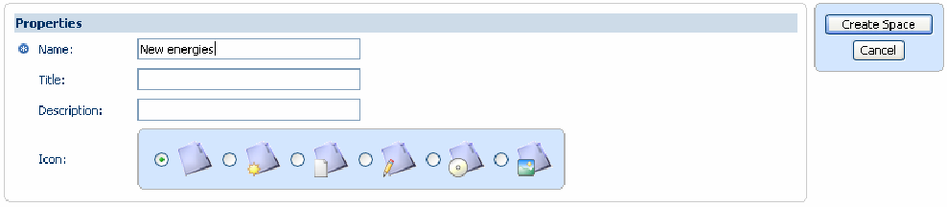
How to create a new space

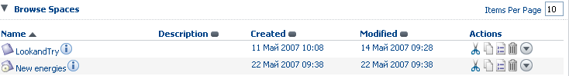
the 'New energies' space has been added to the Library

The 'New energies' is a new sub-space of the Library. We can see its properties as well as the set of actions depending on your role.

By copying a space
Copy spaces can be managed through the "Administration" service, too.
If starting from the main page of the Library:
Click the copy icon () next to the name of the space to be copied.
If starting from the main page of the space to be copied:
Once you have selected the space from the main page of the Library, click more actions/copy command (located in the space toolbar).

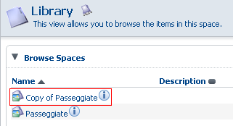
A new sub-space is created from sub-space "Passeggiate"

A message informs you that the space has been successfully added to the clipboard. You will expand the navigator option (look at the up-left corner of the screen) and select shelf in order to reach the clipboard and paste the copied space or cancel the copy/paste action.
Then, you can rename the space: use of the "View details" icon () to edit the properties of the space and change its name and title.

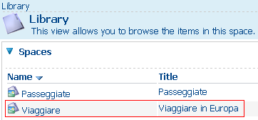
The copied sub-space is renamed as "Viaggiare"

.

No matter when you add sub-spaces; feel free to gradually adapt the library to the growing needs of your Interest Group.

How to delete or recover sub-spaces:
In the same way as you can add sub-spaces to your Library, you can delete some. On the other hand, if you have been too swift to cancel a space, you may wish to recover it. To know more about, just read below.

Deleting a sub-space of the Library
Please, keep in mind that you cannot delete the whole Library. You can just suppress some of its sub-spaces. To delete spaces from the Library, you will fulfil the 'delete Space' dialog. This can be launched from the "Administration" service. Consequently, only those who may administrate the Library can access the deleted spaces or contents.

There are three ways to access the 'delete Space' dialog:
You can display the space in question and select more actions from its toolbar. You press onto the 'Delete' icon ();
You click icon 'More actions' under 'Actions'. You will find there the 'Delete' icon;
You start the action from the 'browse space' section of the parent space main page. This time, you display the "Details" view () of the space to delete. You click "delete" in the Actions list (look at the right column of the details page).

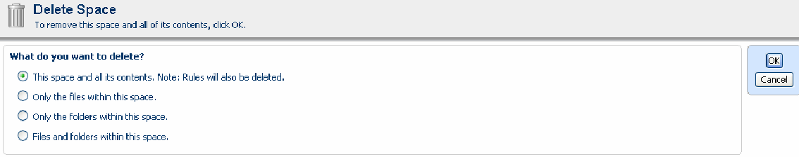
Delete space; one command, four options

Clicking has launched the 'delete Space' dialog. You are proposed to suppress either the whole space or part of it (its sub-spaces only or its content only or both its sub-spaces and content items).
You choose what you wish to erase and click OK.

"I have deleted a space, by mistake. Is it definitely lost?
- Through the "Search for deleted items" function, you can recover any deleted space

Let's see how to recover deleted spaces.

Recovering the deleted spaces
The 'Manage deleted items' functionality enables you to recover or, at the opposite, definitely suppress the spaces or content items that you have deleted during a period which may date back to 30 days.

Are there restrictions in recovering spaces?
Only those who can delete spaces can recover them.
Notice that you can recover only the spaces deleted by yourself.

Where is this function available from?
"Manage deleted items" can be accessed through the "User options" icon () available from the top toolbar of the "Administration" service welcome page.

How to retrieve deleted items
Once you have opened the User options section, click Manage deleted items (located in the "Management" pane, at the bottom of the screen).

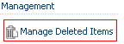
"Manage deleted items" such as available from the User options

The Manage deleted items interface is displayed, enabling you to search with various criteria.

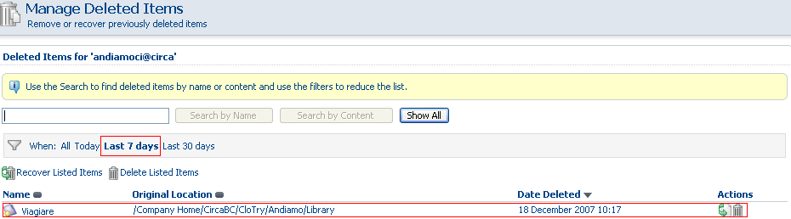
User is looking for the items deleted within the last 7 days

- Deleted spaces or contents can be searched by their name or their content.
Search by name: you can search with any part of the name.
Search by content: you must use whole words. The search engine deals with proximity: the expressions or sentences can be quoted (i.e. 'task force'). The dash in the compounded words is simply ignored by the search engine (right-handed will be found whether searched with word "right", or with word "handed" or even with the string "right handed").
- You can search over a time span (the current day, one week or one month).
- Show all allows you to display all what you have deleted.

The search fields can be combined. By ex., we can ask for a space containing '2007' and having been deleted within the seven last days.

The search comes up with a results list which shows the name, location and deletion date of each relevant item.
This results list gives us an opportunity to either recover or delete definitely the deleted items.

Definite choice

How can I recover deleted spaces?
- Recover listed items
We have looked for some spaces. Our research comes up with several results, all of them finally appearing as relevant to our current concern. So we should like to recover all of these deleted spaces at one time. This is possible by clicking the Recover listed items icon () at the top of the results list.
Otherwise, if we prefer to delete these spaces, definitely, we click the Delete listed items icon ().

- Recover a specific item
We have looked for all the spaces and contents we have deleted today. We decide to recover only one space. In the below figure, the space to be recovered is titled "Whynot".

We click the Recover icon () next to "Whynot".
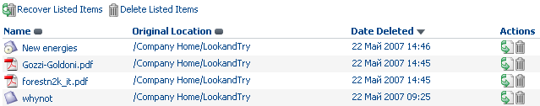
Space "whynot" is ready for recover

We are proposed to choose the location where the space should be restored. This place, indeed, may be different from the initial one.
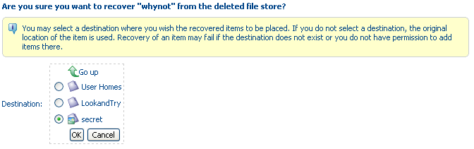
Space "whynot" will be recovered under space "secret"

If need be, we indicate the destination before confirming our wish to recover "Whynot"(top right ok button).

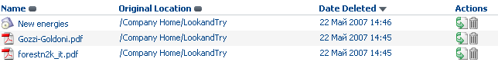
Further to recovering space, "whynot" is removed from the results list

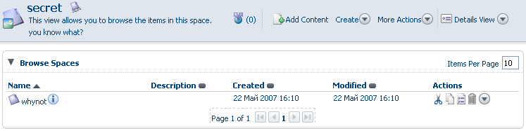
It is now listed as a sub-space of space "Secret"

We have now come to an end with the delete/recover spaces of your IG Library.
The more actions menu of the library allows some common actions such as cutting, copying spaces while the properties allow you to change the name or the description of any space.

Some more actions (move, rename)

How to move a sub-space
To move a sub-space to another space is very easy to do. Just click the cut icon in the more actions menu (to be selected from the toolbar of the space welcome page).
Once cut, the space appears in the clipboard (accessible through "navigator"/"shelf"). The clipboard contains the "Paste" and "Remove" options. Notice that "remove" simply means the removal of the item from the clipboard. This will not delete it from the Library.

How to rename a sub-space
You may change the name of any space.
To do so, you select view details () from more actions (in the toolbar of the space welcome page). The details of the Library are displayed.
You press the "modify" icon () in the top bar of the 'properties' pane. The 'Modify Space Properties' dialog is launched. You put a new name. Notice that you are free to change other parameters such as the space icon, title and description.
Then just click OK in order to validate the changes.

Managing the content of a library
As an IG leader you can add, create, modify and delete content. You can run specific actions over the content such as adding translations.

About multilingualism

Dealing with multilingualism
Dealing with multilingualism is one of the CIRCABC main features. CIRCABC indeed sets relations between a given content and all its translations. This means that you can display contents in your favourite language. If the requested translation is not (or not yet) available, you can read some content properties in your language.

The CIRCABC Users guide provides a detailed description of how CIRCABC deals with multilingualism (see "How to deal with multilingualism", pp. 31-49).

Some more about multilingual spaces

What is a multilingual space?
CIRCABC enables you to create multilingual spaces. These spaces have some of their properties (title and description) translated in the languages you wish. So, most members of a multilingual Interest group can consult spaces in their native language.

How can I make a space multilingual?
In the top toolbar of the library's welcome page, click Create/create multilingual space. The "create space" dialog is opened. At first glance, the creation procedure is quite common. You are asked for providing name, title, and description for the new space. But, very quickly, you will notice the specificity of the "create multilingual space". At the bottom of the creation screen, indeed, you are proposed to edit the space multilingual properties. By editing these properties, you can translate them in the languages you need (to be chosen from a scroll-down list).

In the example below, the properties have been initially created in Italian. We need to add their translation in English and in German:

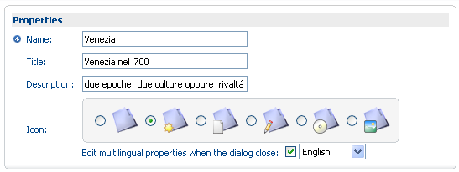
Creating a multilingual space

First, we key in the properties in the original language (Italian, there). Once done, we check "Edit multilingual properties (…)". Then we press on the "create multilingual space" button (next to the properties pane).

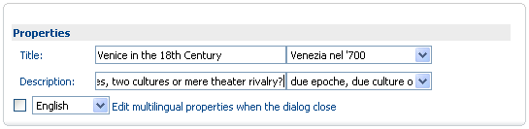
Adding properties to a multilingual space

The properties are edited as a two-column table. The column on right contains the just-added linguistic version while the column on left remains empty. The language we have chosen for the new translation appears at the bottom of the edit properties pane. In the example above, we add an English translation. As we wish to add also a German version, we cross again "Edit multilingual properties (…)" and select German. Then we click "create multilingual space".
So long as you cross the "Edit multilingual properties (…)", you are given the opportunity to add properties in other languages. Once you have created the title and description in all the languages you need, just press the "create multilingual space" without crossing this option any longer.

Now the space properties will be displayed in English for the members who will consult your IG in this language while the German or Italian speakers will be able to access them in their own language.

How to add content
You can learn how to load content in "Add content into the Library" (see CIRCABC Users guide, pp. 26-27).

Deleting or recovering content

Deleting content
You display the properties of the content by pressing onto the "View details" icon (). Then pick the command "Delete" () out of the actions list which can be found on the "content properties" page.
The "delete" function applies independently of the nature of the item (space as well as content). Detailed information can be found in "deleting a sub-space" (in "How to delete or recover sub-spaces", p. 20).

Recovering deleted content
You select "Manage deleted items" from "More actions" in the top toolbar of the "Administration" service welcome page. Detailed information is provided in "recovering deleted items" (in "How to delete or recover sub-spaces", p. 21).

Well! Now you are able to organise the spaces in your Library. As a leader, you can perform more complex actions.

How to deal with content versioning

About Versioning
By "versioning" contents, we can follow up the successive states of a content which has been modified at several times. Versioning means numbering a series of versions of a same content. What's more, it enables us to read this content, or its properties, at any state of its elaboration.
It is for you to make contents "versionable" (except multilingual contents, which are "versionable" by default). To make a content ready to receive a version number, you display its properties (via the icon ) . You will notice, among other details, a pane dedicated to "version history". Such "version history" is set by default to status "Allow versioning".

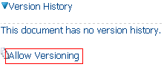
Version properties before the content to be made "versionable"

By pressing onto the link "Allows versioning", you initiate the versioning of the content. The properties page is refreshed and area "version history" is updated with a version number.
As soon as uploaded, any content starts with Version 1.0. The version number is automatically incremented after each content modification.

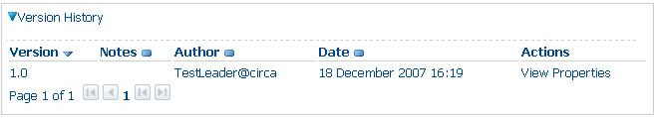
The version history once user has clicked "Allow versioning"

How to follow up the versioning of a content
All the versions of a same content are listed in the 'version history' section of the content properties page (accessible through icon ). Each of them comes along with:
- its number;
- notes;
- the name of its author;
- its creation date;
- access to the full text of the corresponding content (link "View");
- access to the properties of the corresponding content (link "properties").

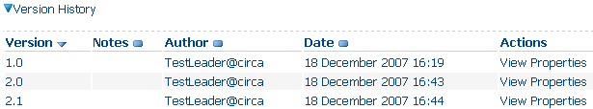
How to follow up a document

In the above example, "2.0" corresponds to some major change while "2.1" represents a minor change.

The number of the current version can also be seen in the content properties (in the content 'Details' view), under 'Version label'.
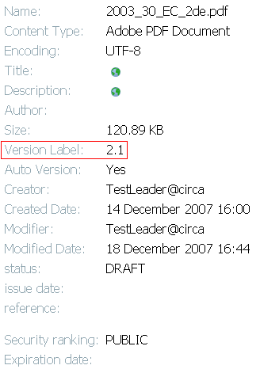
The current version is listed among the content properties

How to update, edit and modify a content

Updating a content
Detailed information is available in "Update a document" (CIRCABC Users guide, p. 24-25).

Check out/in
This process has been explained in "Check out any content and check in", (CIRCABC Users guide, p. 23-24).

Managing the Library users
The "User management" section deals with changing the rights for the whole Interest Group. We shall now explain how to modify the role played by a Member in the only library or even a part of the Library.

Which roles for the Library?
Let us take an eye to the range of roles that may be offered to IG members in the Library:
No access: the access to the Library is denied.
Access: only allows reading contents; you can only download contents as well as their properties.
Edit only: you can only edit contents; you cannot create nor delete any.
Manage own: you can create, edit and delete your own contents. You can only access the documents created and managed by the other members.
Full edit: you can create contents; you can edit any content whoever be its author. But you can delete only your own contents.
Administrate: basically, you have as many rights as the full-edit role. Additionally, you can delete any content. Moreover you can organise the Library and manage its users.

The roles in the library are related to the access profiles (default or created by yourself or any other Members administrator).

Changing a user's role in a space of the Library (for further release)

How to give more rights
In the following example, the Library contains three sub-spaces:

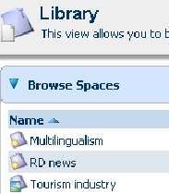
Spaces in a Library

Mrs Stella Karoli, a member of our interest group, has very few rights over the Library but is about to collaborate more and more in our "Tourism industry" section while continuing not to act in "Multilingualism" nor "RD News". We shall change her role in the "Tourism industry" sub-space without changing her rights on the rest of the Library.

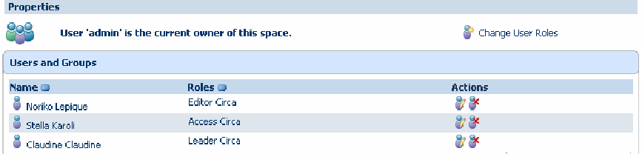
Ms Karoli can access the whole Library with an Access role

We enter the Interest Group. We go to the main page of the "Tourism industry" sub-space. Once there, we choose 'more actions'/'manage user rights' from the sub-pace top toolbar.

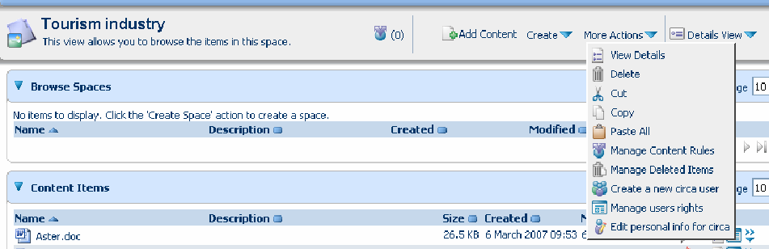
How to access the Manage users rights functionality

Such selection takes us to the list of users like below:
The users list

We click "Change user role" and get a form allowing us to:
- Select the user whose role will be modified
- Select a new role for this user

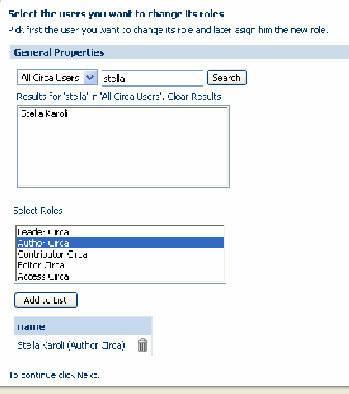
Change user procedure

We look for Stella Karoli. We select Stella Karoli from the results list; we pick role "Author" out of the "select role" list; we press on "Add to list". As a result, the page is refreshed with Stella Karoli appearing in the "Name" section located at the bottom of the page. We click 'next' and reach a page asking whether we wish to notify the user or not.
We answer this request and click "Finish".

As from now, the users list for the "Tourism industry" section will show Author as role while remaining Access at the Library level.

We can figure this change by showing what our IG member can do on the "Aster" document, a document of the Library which had been previously copied to the "Tourism industry" sub-space:

Ms Karoli has very few rights over the content "Aster" such as outside "Tourism industry"


She has more rights over the content "Aster" such as inside "Tourism industry"

That is all what you need for starting with the library management. Working in the Library, you or any of your IG members will also need to make searches. This is the main topic of next chapter.

About the general and advanced search

Which kind of search?
The search engine explores both the properties and the contents of your IG content.

…You are telling about text search. But what about the items which consist exclusively of information other than text?
- No matter, such items are put in relation with textual data (their name or description, for instance). The search engine explores their name. What's more, the advanced search offers you to ask for the engine to select only files in a given format (sound, picture, email, etc).

The general search
The general search allows you to ask for text to be retrieved from the name and/or the informational content of any space or content.
The general search is run from the search box in the up right corner of the screen.
You will know more about how to deal with the General Search by reading "About the general Search" (CIRCABC Users Guide, pp. 50-53).

Build detailed queries with the advanced search
The general search enables you to perform the most frequent queries. Therefore, you can take advantage of the Advanced Search to execute finer searches.
The advanced search is purposed to building queries involving dates, time spans, specific file formats … You can also use it in order to only search in specific sub-spaces.
You can find some more about how to deal with the Advanced Search in "About the advanced search" (CIRCABC Users Guide, pp. 53-55).

Save and re-use queries
CIRCABC enables you not to repeat iterative searches. You can save your general and advanced queries for further re-use.
This matter is explained in "Save and re-use queries" (CIRCABC Users Guide, chapter 9, paragraph 9.4, pp. 50-51).

Such are the key elements to become familiar with managing the content of your Interest Group. You are now able to create, modify, update or delete content. You are able to deal with searching.
As leader, you will have, also, to manage the users of your Interest Group, that is to say to adapt their profile to your library, either that they request for playing a different access profile in the Library or that you estimate their current access profile to be irrelevant.

As a manner of conclusion

This Leader guide helps you to deal with the main features of CIRCABC Version 1.0. The CIRCABC Leader guide will be updated so as to match the evolution of CIRCABC. So, if encountering any difficulty, do not hesitate to take another look at it!

FAQs and online help will come and contribute to bring swift answers to precise questions.

Before coming to an end, we would like to wish you a nice getting in touch with CIRCABC.

Further information on OSS is available at http://ec.europa.eu/idabc/en/document/2627/5894

